H |  | NANYANG JUNIOR COLLEGE  JC 2 PRELIMINARY EXAMINATION  Higher 2
CANDIDATE
NAME

CANDIDATE  NAME |  | ANSWERS
CLASS |  |  |  | TUTOR’S NAME
CHEMISTRY |  |  |  | 9647/02
Paper 2 Structured |  |  |  | 21 September 2010
 |  |  |  | 2 hour
Candidates answer on the Question Paper

Additional Materials: Data Booklet

READ THESE INSTRUCTIONS FIRST
Write your name and class on all the work you hand in.
Write in dark blue or black pen on both sides of the paper.
You may use a soft pencil for any diagrams, graphs or rough working.
Do not use staples, paper clips, highlighters, glue or correction fluid.

Answer all questions in the spaces provided.
A Data Booklet is provided.
At the end of the examination, fasten all your work securely together.
The number of marks is given in brackets [ ] at the end of each question or part question.
 |  |  |  |  |  |  | For Examiner’s Use
 |  |  |  |  |  |  | 1
 |  |  |  |  |  |  | 2
 |  |  |  |  |  |  | 3
 |  |  |  |  |  |  | 4
 |  |  |  |  |  |  | 5
 |  |  |  |  |  |  | 6
 |  |  |  |  |  |  | 7
 |  |  |  |  |  |  | 8
 |  |  |  |  |  |  | 9
Total
[72]
This document consists of 16 printed pages.

Answer all questions in the spaces provided.

1 Planning (P)
Commercially prepared aspirin is not 100% pure as it hydrolyses slowly when exposed to moisture in the air. Aspirin which has not been properly sealed may give off a vinegar smell.

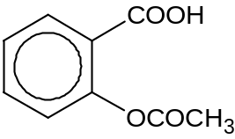
Aspirin, M_{r} 180

You are to design a titrimetic analysis to determine the purity of a sample of commercial aspirin which has been exposed to air for some time.

You are provided with the following:
about 4.5 g crushed aspirin
0.100 mol dm⁻³ NaOH
0.100 mol dm⁻³ HCl
any other chemicals and apparatus found commonly in the laboratory

The experiment will take place in four stages:

Stage 1 Preparation of aspirin solution
Stage 2 Titration of aspirin sample with NaOH
Stage 3 Hydrolysis of titrated sample with excess base
Stage 4 Titration of resultant sample with HCl

- Explain why it is not advisable to simply use the titration results from Stage 2 to determine the purity of the aspirin tablet. [1]

  - Since some hydrolysis has already taken place, ethanoic acid produced will also react with NaOH during titration.
  - Hence volume of NaOH titrated will be higher than expected.

1 mark for both points

- Name a suitable indicator for the experiment and state the colour changes seen at both end-points in Stage 2 and Stage 4. [2]

Phenolphthalein; [1]
Stage 2: colourless to pink
Stage 4: pink to colourless [1 for both points]

- (i) Briefly outline, in a step by step procedure, how you would prepare the
aspirin solution in Stage 1 and use it to perform the titration in Stage 2.
In your answer, include the following:
  - a suitable solvent,
  - any measurements you would take,
  - any suitable lab apparatus used and
  - appropriate volumes or masses of reagents used. [4]

- With an electronic balance, weigh a clean and dry beaker.
- Weigh 4.5 g of aspirin and place in the beaker.
- Dissolve the aspirin in ethanol and transfer to a 250 cm³ graduated flask with a funnel.
- Rinse the beaker and pour the washings into the flask. Repeat this at least twice.
- Mix thoroughly by inverting and shaking.
- Pipette 25.0 cm³ of the solution into a conical flask.
- Place 2-3 drops of phenolphthalein into the conical flask.
- From a burette, slowly add NaOH until the mixture turns a permanent pale pink.
- Repeat steps 6 – 8, as necessary, to achieve consistent results.

  - Solvent is a polar organic solvent e.g. alcohol [1]. Other alternatives like benzene can be accepted.
  - Correct procedure (Step 1, 2, 3, 4, 5) and apparatus for Stage 1 [1]
  - Correct procedure (Step 6, 7, 8, 9) and apparatus for Stage 2 [1]
  - Appropriate masses and volumes used [1]

    - Deduce the volume of NaOH that should be added in Stage 3, based on your proposed procedure from (c)(i). [1]

Minimum volume of NaOH required to hydrolyse aspirin sample
= (25.0/250) × (4.5/180) / 0.100 = 25.00 cm³
Volume of NaOH used = 25.00 + 10.00 cm³ [1]

    - By using volumes which you proposed in (c)(i) and (ii), show how the percentage purity of the commercial aspirin sample can be calculated from your titration results in Stage 4. [3]

Let vol of HCl titrated be x cm³ and mass of aspirin weighed be m_{sample}.
Volume of NaOH in excess = x cm³
Volume of NaOH reacted with aspirin = (35.00 - x) cm ³
Amt of aspirin present in 25.0 cm³ = (35.00 – x) (0.100) mol [1]
Amt of aspirin present in 250 cm³ = (35.00 – x) (0.100) (250 / 25.0) mol [1]
Mass of aspirin, m_{aspirin} = (35.00 – x) (0.100) (250 / 25.0) (180) g
Purity of aspirin = 100 m_{aspirin} / m_{sample} [1]

- The NaOH solution provided was not standardised before the experiment. What is the impact of this error on the calculated results? [1]
NaOH solution can absorb CO₂ if exposed to air. Actual concentration is lower than the stated value, hence calculated purity is higher than actual.

[Total: 12]

2 Boron trifluoride, BF₃, reacts with sodium fluoride to form a salt, S.

(a) Draw the structural formula of the anion of S, showing the formal charges, if any, on each atom.

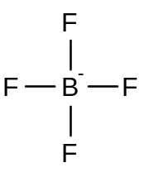
(1)

[1]

(b) The bond angle in the BF₃ molecule differs from that in the anion of S. By considering the numbers of electron pairs, draw diagrams to show the likely shapes of the two species. State the values of the bond angles.

BF₃  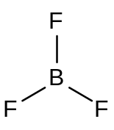  (1) | anion of S  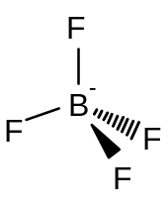  (1)  do not penalise charge or lack of dative bond
Bond angle = 120° | Bond angle = 109.5° or 109°  (1) for both bond angles
[3]

[Total: 4]
3 One reaction which occurs in air polluted with nitrogen oxides is shown below.
2NO(g) + O₂(g) → 2NO₂(g)
Two experiments were carried out to find the relationship between the initial concentration of NO and of O₂ and the volume of NO₂ produced. The results were plotted below.

Experiment 1 Experiment 2
0.200 or (any value > 0.100)
[NO] = 0.100 mol dm⁻³ [NO] = mol dm⁻³
0.001
[O₂] = 0.001 mol dm⁻³ [O₂] = mol dm⁻³

Volume of NO₂
time
V_{o}
Volume of NO₂

V_{o}



1st t_{1/2}
2nd t_{1/2}

time

(a) The results of experiment 1 allowed the order of reaction with respect to one of the reagents to be found.

(i) State which reagent and explain your reasoning.
 O₂. In Expt 1, a huge excess of NO is used. Hence [NO] remain relatively constant as reaction proceeds. The apparent overall order of reaction depends only on the order with respect to O₂, which will determine the shape of the graph.

(ii) Deduce the order of reaction with respect to the reagent, showing your working on the graph for Experiment 1.
 1st order
[3]

(b) In the boxes above, suggest possible concentrations for NO and O₂ in experiment 2.
[1]

(c) Catalytic converters are used to remove nitrogen oxides from vehicle exhaust gases. They consist of a chamber of porous material coated with platinum through which the exhaust gases must pass. The platinum will catalyse the reduction of the nitrogen oxides to nitrogen.

Explain how platinum is able to catalyse the reduction of nitrogen oxides.

The reactants molecules are chemically adsorbed on neighbouring active sites on the catalyst, increasing the surface concentration of the reactant molecules.  The activation energy decreases due to the weakening of the covalent bonds within the reactant molecules  and aid in the formation of the product molecules.
[2]

[Total: 6]

4 The table below shows the dissociation equations of hydrofluoric acid, methanoic acid and disodium hydrogen phosphate and the values of their respective dissociation constants. You are to use the following information to answer (a) and (b).

Dissociation equations | Dissociation constants / mol dm⁻³
HF + H₂O 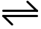 F⁻ + H₃O⁺ | K_{a} = 6.8 x 10⁻⁴
HCOOH + H₂O HCOO⁻ + H₃O⁺ | K_{a} = 1.8 x 10⁻⁴
HPO₄²⁻ + H₂O H₂PO₄⁻ + OH⁻ | K_{b} = 1.6 x 10⁻⁷

(a) For the following reaction:

H₂PO₄⁻ + F⁻ HPO₄²⁻ + HF

(i) identify the one conjugate acid-base pair,

H₂PO₄⁻/ HPO₄²⁻ or HF/ F⁻ [1]

(ii) predict, with reasons whether the equilibrium constant will be greater than
or less than 1. [3]

The equilibrium constant will be less than 1.
HF has a larger K_{a} than H₂PO₄⁻ and will donate proton more readily.
HPO₄²⁻ has a larger K_{b} than F⁻ and will accept proton more readily.
Thus the reaction between HF and HPO₄²⁻ takes place more readily, favouring the backward equation.

1 mark for the correct prediction; award only if explanation shows understanding
1 mark for the correct explanation

(b) Two solutions of pH 4.00 were prepared.

- Solution A contains 0.0113 mol dm⁻³ methanoic acid and 0.0200 mol dm⁻³ sodium methanoate
- Solution B contains 0.00113 mol dm⁻³ methanoic acid and 0.00200 mol dm⁻³ sodium methanoate

(i) Calculate the change in pH when 0.0500 cm³ of 1.000 mol dm⁻³ HCl is added to 100.0 cm³ of each of the two solutions. In this part, give your final answers to 3 siginificant figures.

Solution A
n(HCl) = 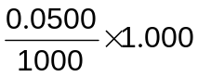= 5.00 x 10⁻⁵ mol [1st]

n(salt) left
= 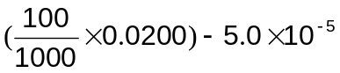
= 0.00195 mol [2nd]

new n(acid)
= 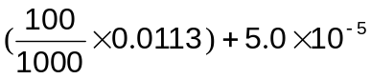
= 0.00118 mol [3rd]

New pH
= − lg(1.8 x 10⁻⁴) + lg 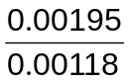 [4th: correct buffer equation used]
= 3.96

Change in pH = 4.00 – 3.96 = 0.0371

Change in pH = 0.0371 [5th]
Solution B

n(HCl) = 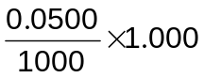= 5.00 x 10⁻⁵ mol

n(salt) left
= 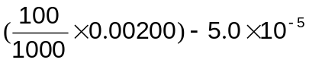
= 1.50 x 10⁻⁴ mol [6th]

new n(acid)
= 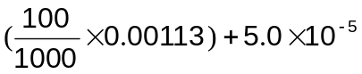
= 1.63 x 10⁻⁴ mol [7th]

New pH
= − lg(1.8 x 10⁻⁴) + lg 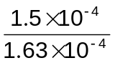
= 3.71

Change in pH = 4.00 – 3.71 = 0.291
Change in pH = 0.291 [8th]

Award 4 marks for obtaining all 8 marking points
3 marks – 6 marking points
2 marks – 4 marking points
1 mark – 2 marking points
Deduct 1 mark from the overall marks awarded for this part if student miss out any unit
Deduct 1 mark from the overall marks awarded for this part if student did not give final answers to 3 sig. fig.

(ii) Explain the difference in the buffering effect of the two solutions. [5]

Solution A has a higher buffering effect than solution B. The components of the buffer in solution B are more diluted (or less concentrated). As such the addition of HCl to solution B changes the concentration of the components in solution B more than in A, resulting in a larger change in pH.

It is acceptable if student explains from the perspective of solution A.
Award 1 mark if explanation shows correct understanding

[Total: 8]

5(a) 5.00 g of calcium nitrate was heated in a heating tube. The mass of the residue in the heating tube was followed as the experiment progress. The following results were obtained.
mass of residue /g
time
5.00
0

    - Write a balanced equation for the decomposition of calcium nitrate. [1]

Ca(NO₃)₂(s) →CaO(s) + 2NO₂(g) + ½ O₂(g)

    - Using the same axes, sketch how the decomposition of 5.00 g barium nitrate varies over time. [1]

    - Explain the difference in the ease of decomposition. [2]

- Ba²⁺ has a larger ionic radius, hence charge density (thus polarising power) of Ba²⁺ is smaller than Mg²⁺.
- The electron cloud of nitrate (for Ba(NO₃)₂) becomes less distorted or less polarised and hence breaks up less readily, and hence decomposition/thermal stability increases.

[Total: 4]
6(a) Compound X is a sodium halide. It reacts according to the following flow-chart.
X
precipitate
colourless
solution
mixture of white and brown fumes
brown
solution
violet organic
layer
conc. H₂SO₄
AgNO₃(aq)
CCl₄
conc.
NH₃(aq)
bubbled
into solution Y

- From the reactions above, identify the halide in X.

Bromide or Br⁻ 

  - What is the colour of the precipitate formed with AgNO₃(aq)?

Cream 

  - Write balanced equations for the reaction of X with concentrated sulfuric acid.

H₂SO₄ + NaBr → HBr + NaHSO₄ 

H₂SO₄ + 2HBr → SO₂ + 2H₂O + Br₂ 

  - Identify the anion in Y and state the type of reaction that Y undergoes to produce the brown solution.

Anion in Y is iodide 

Type of reaction is redox or displacement reaction 

[Total: 6]
7 Besides showing the usual group trends, the first three elements of the second period also show diagonal relationships to elements of the third period in the next group. Thus, the elements in the pair beryllium/aluminium and boron/silicon show similar properties.

(a) Suggest why these pairs of elements show diagonal relationships.
Similar electronegativities OR similar charge density [1]

- (i) Write equations for the reaction of the chlorides of aluminium and silicon with water.
AlCl₃ + 6H₂O → [Al(H₂O)₆]³⁺ + 3Cl⁻
[Al(H₂O)₆]³⁺ + H₂O(l) [Al(H₂O)₅OH]²⁺(aq) + H₃O⁺(aq) [1]
SiCl₄ + 4H₂O → Si(OH)₄ + 4HCl [1]

(ii) Describe the reactions, if any, of the chlorides of boron and beryllium with water, suggesting the pH of the resulting solutions and writing equations where appropriate.

BeCl₂ and BCl₃ are covalent chlorides with a simple molecular structure. They undergo hydrolysis in water to form acidic solution, similar to AlCl₃ and SiCl_{4.} [1]

BeCl₂ + 4H₂O → [Be(H₂O)₄]²⁺ + 2Cl⁻
[Be(H₂O)₄]²⁺(aq) + H₂O(l) [Be(H₂O)₃OH]⁺(aq) + H₃O⁺(aq) [1]
pH of aqueous BeCl₂ = 3 [1]

BCl₃ (l) + 3H₂O(l) → B(OH)₃(s) + 3HCl (aq) [1]
pH of aqueous BCl₃ = 2 [1]

[Total: 8]
8(a) Chromium is a transition element that has variable oxidation states and many of its compounds are coloured.

(i) A piece of chromium metal is added to a solution containing chromium(III) ions. Use the relevant data from the Data Booklet to predict the reactions, if any, that occur. State the colour change observed, if any.
E/V
Cr³⁺(aq) + e⁻ 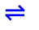 Cr²⁺(aq) –0.41
Cr²⁺(aq) + 2e⁻ Cr(s) –0.91
[1]
Using the correct half equations:
Overall reaction equation: Cr(s) + 2Cr³⁺(aq) 3Cr²⁺(aq)
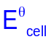 = –0.41 – (–0.91) = +0.50 V > 0; reaction is feasible. [1]
Green solution of Cr³⁺ turns blue due to the formation of Cr²⁺. (Effervescence is also observed.) [1]

(ii) Potassium dichromate(VI) can be converted to chromium(III) by a transition metal cation of +2 charge. Suggest the identity of this transition element.

Any of the following: Fe²⁺, Cr²⁺, V²⁺,VO²⁺ [1]
[4]

(b) Compound Z was warmed with acidified aqueous potassium dichromate(VI). The structure of Z is shown below.

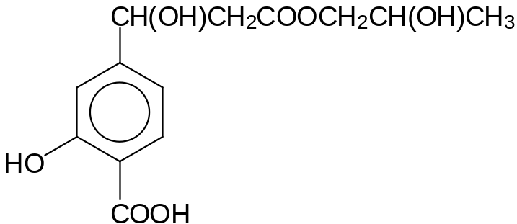

Compound Z

(i) Name all the functional groups that are present in compound Z.
Phenol, carboxylic acid, secondary alcohol, ester [2]

(ii) Draw the structures of all the organic products from this reaction.

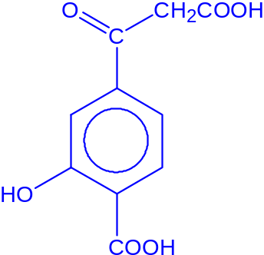[1] 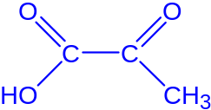 [1]
[4]

[Total: 8]

9(a) The following table shows the enthalpy change of hydrogenation of two dienes:
2-methylbuta-1,3-diene and penta-1,4-diene.

Diene | Product | Enthalpy change of hydrogenation/ kJ mol⁻¹
Diene | Product | Expected, a | Observed, b | Difference  (a – b)
CH₂=CHC(CH₃)=CH₂  2-methylbuta-1,3-diene | CH₃CH₂CH(CH₃)₂ | – 244 | – 229 | – 15
CH₂=CHCH₂CH=CH₂  penta-1,4-diene | CH₃CH₂CH₂CH₂CH₃ | – 252 | – 253 | 1

- The enthalpy change of hydrogenation data shows that 2-methyl-buta-1,3-diene is more stable than expected. Explain by making reference to the p orbitals in the molecule.

2-methyl-buta-1,3-diene is a conjugated diene. The extent of overlap of the unhybridized p orbitals of the 4 sp² C can overlap with each other causing the π electrons to spread out, or delocalize over the entire π framework (or over the 4 carbon atoms). Electron delocalization leads to a lower energy and hence leads to stability.

- Deduce whether the bond length between C2 and C3 in 2-methyl-buta-1,3-diene is shorter or longer than that between C2 and C3 in penta-1,4-diene.

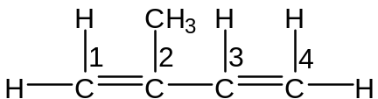 | 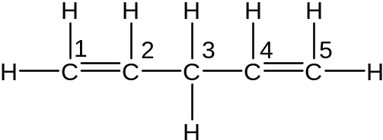
2-methyl-buta-1,3-diene | penta-1,4-diene
The bond length will be shorter due to sp²-sp² overlap that strengthens the bond between C2 and C3.

- The following diene

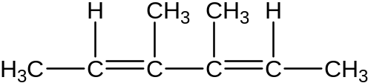

was treated with hydrogen in the presence of a nickel catalyst to form a mixture of four isomers with molecular formula C₈H₁₆.
Draw diagrams to illustrate all the isomers.

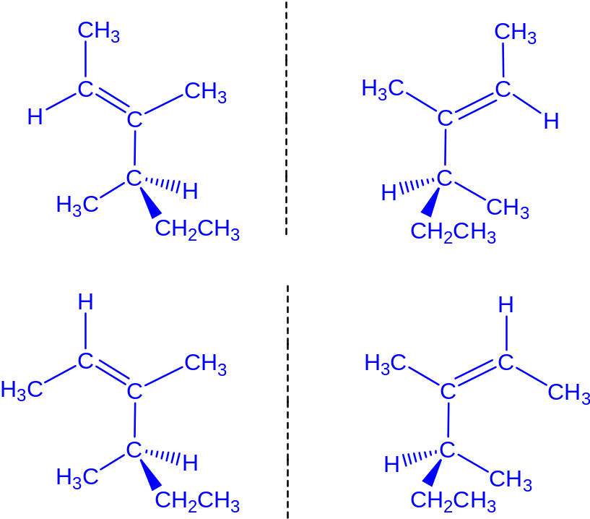
[7]

(b) (i) Describe a chemical test by which you could distinguish the following pair of organic compounds. State the reagents and conditions and the observations with each compound in the spaces provided.

Reagents and conditions: Tollen’s reagent, warm

 | 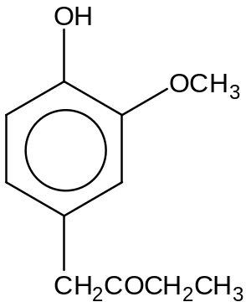 | 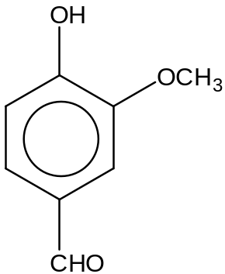
Observation | No Ag mirror is formed. | Ag mirror is formed.

(ii) Draw the structure of the organic product that is formed for the compound that gives a positive test in the space provided.

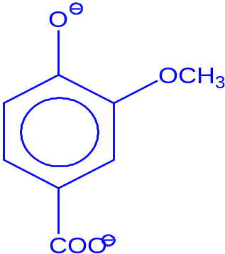

[3]

[Total: 10]
10 Bovine insulin is a hormone that regulates glucose metabolism. It consists of two polypeptide chains. The A chain contains 21 amino acid residues while the B chain has 30. The diagram below shows the structure of the B chain with three segments labeled J, K and L.

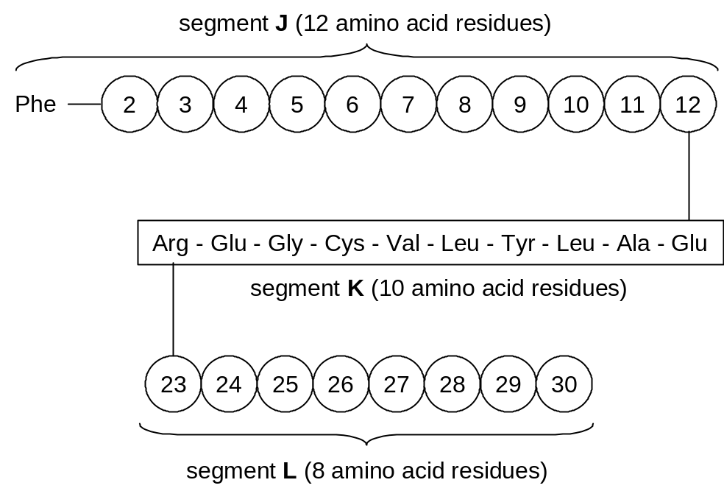
B chain of bovine insulin

(a) What is meant by the primary structure of a protein? [1]

sequence of amino acid in the polypeptide (1)

(b) The B chain was first treated to yield segment L as a free polypeptide chain of eight amino acid residues. Analysis of the free polypeptide L found that it contained the following amino acids.

Amino acid |  | Formula of R | Number of residues
alanine | Ala | −CH₃ | 1
glycine | Gly | −H | 1
lysine | Lys | −CH₂CH₂CH₂CH₂NH₂ | 1
phenylalanine | Phe | 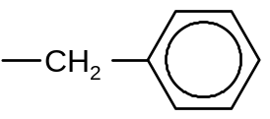 | 2
proline | Pro | 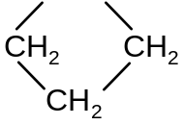 (cyclic) | 1
threonine | Thr | −CH(OH)CH₃ | 1
tyrosine | Tyr | 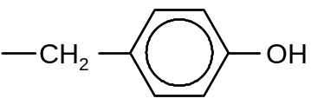 | 1

Analysis of the N-terminus showed that it contained an amino acid which is optically inactive.

Hydrolysis of L with the enzyme chymotrypsin, which hydrolyses at the carboxylic end of tyrosine, produces two tetrapeptides.

Partial hydrolysis of L gives a mixture of fragments. Three of the fragments are Lys-Ala, Gly-Phe and Thr-Pro-Lys.

(i) Draw the displayed formula of the dipetide Gly-Phe.

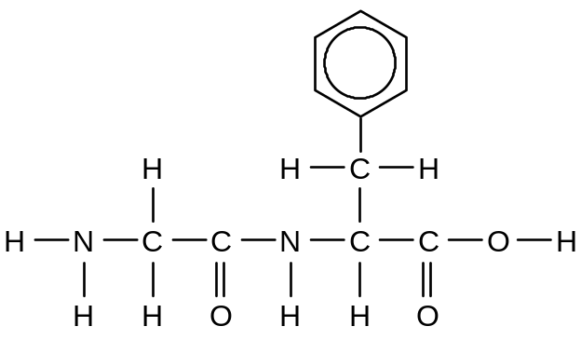
(1)

(ii) Deduce the amino acid sequence of L.
Gly – Phe – Phe – Tyr – Thr – Pro – Lys – Ala (3)
[4]
(c) One of the amino acid residues P in segment K of the B chain is covalently bonded to an amino acid residue Q in segment M of the A chain in bovine insulin.

segment M of A chain

segment K of B chain

The R groups of the amino acids are given below.

Amino acid |  | Formula of R
alanine | Ala | −CH₃
arginine | Arg | 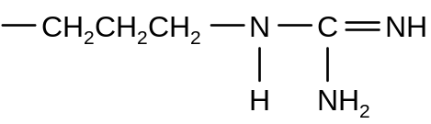
asparagine | Asn | −CH₂CONH₂
cysteine | Cys | −CH₂SH
glutamic acid | Glu | −CH₂CH₂CO₂H
glutamine | Gln | −CH₂CH₂CONH₂
glycine | Gly | −H
leucine | Leu | −CH₂CH(CH₃)₂
serine | Ser | −CH₂OH
tyrosine | Tyr
valine | Val | CH(CH₃)₂

Suggest the identities of P and Q and name the linkage between them.
P: Cys Q: Cys (1) for both P and Q
Name of linkage: disulfide linkage (1) [2]

[Total: 8]

